Peer review- Oxytocin

Reviewed by: Julia waldmeier, Sara Carvalho Fangueiro, and Henriette Ruckert

Documentation file

1. Translation of OXT gene into preprohormone

The main transcript of the OXT gene can be found circled in red below.
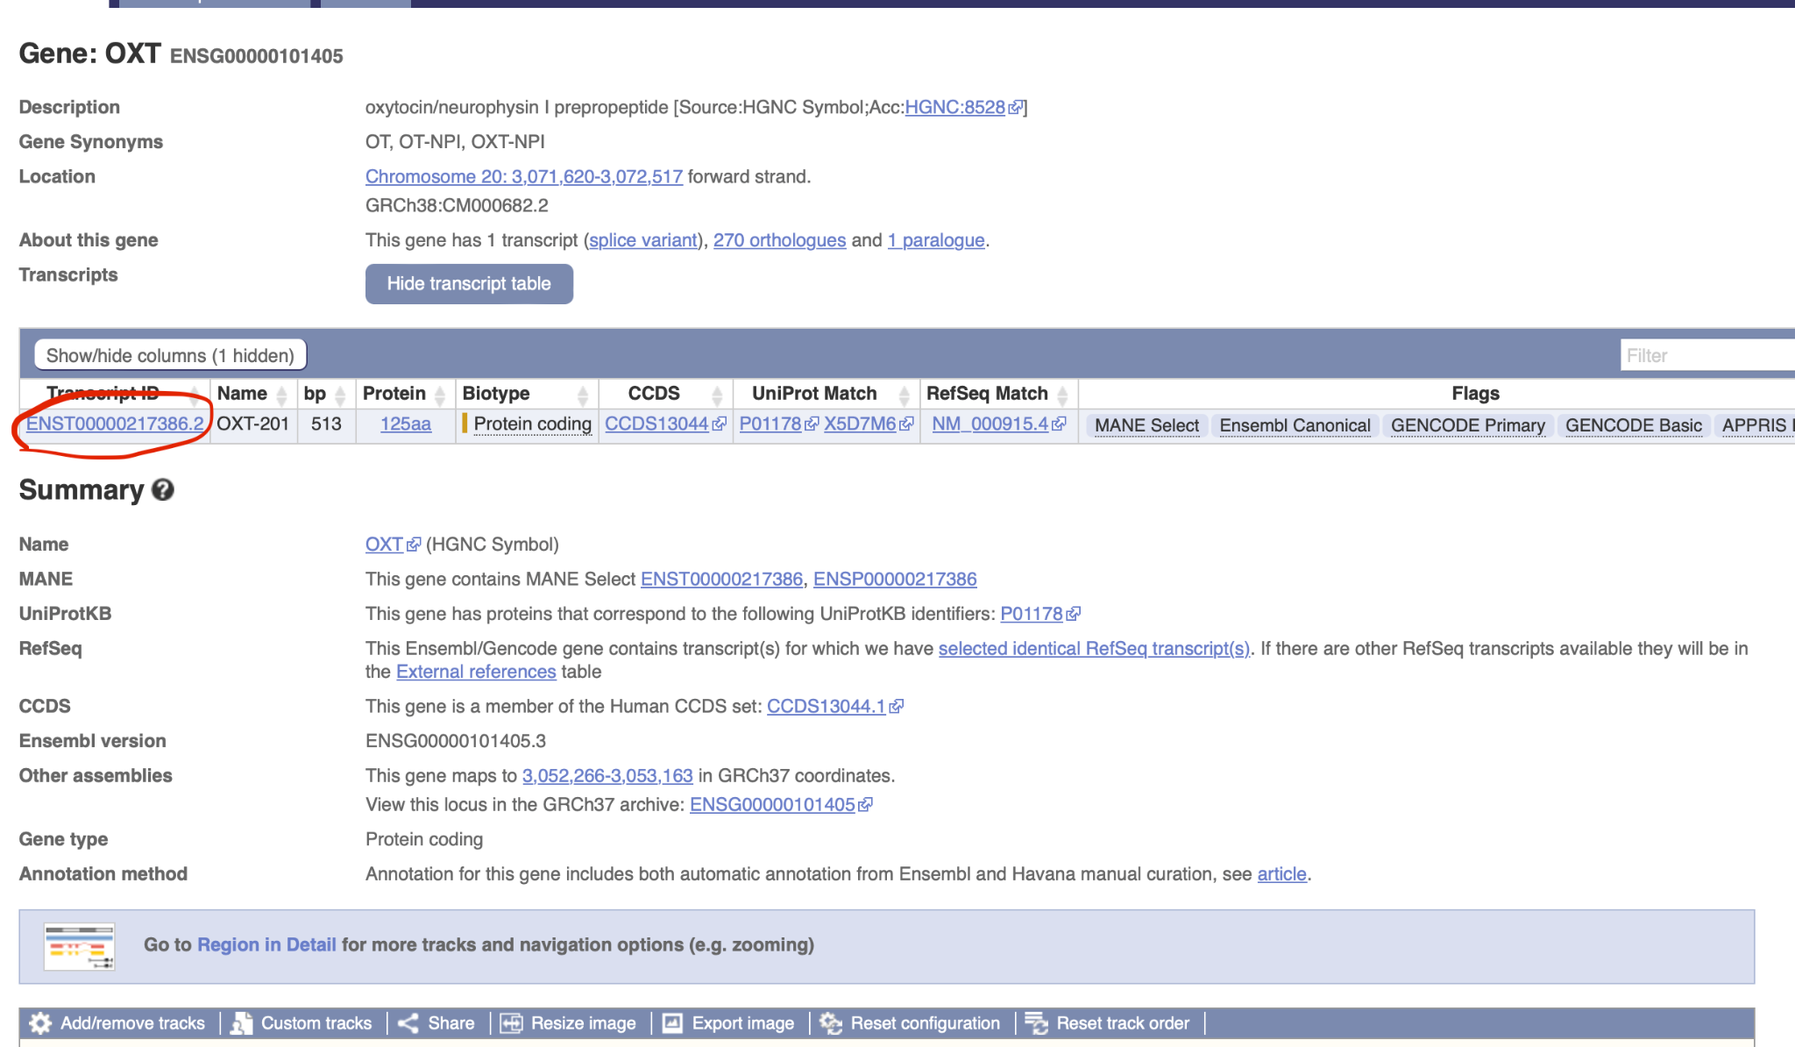
Instead of the 2 transcript IDs you included, perhaps use this one instead.

Looking at the rest of the steps of the biosynthesis pathway, it seems that you have included the incorrect main transcript for each gene, however this can be fixed by referring to the image above and with the same format find the correct Main transcript ID that contains the MANE select flag and the rest of the Ensembl flags.

Reactions
For the reactions, maybe include the place in which the reaction happens according to the [letter] chosen. For example in this reaction prepro-oxyphysin-1[c] → prepro-oxyphysin-2[c], you could later include “c standing for cytoplasm”.

SRP
SRP is a ribonucleoprotein complex, and not an “enzyme”, so maybe replace “enzyme” to “complex”, so it makes sense adding the GPR rules.

3. Cleavage of preprohormone signal peptide catalysed by a peptidase

The hormonal precursor pro-ocytocin-neurophysin is activated by selective cleavage at Arg12-Ala13, producing mature ocytocin and neurophysin. https://pubmed.ncbi.nlm.nih.gov/9862210/

This sentence should be on step 7.1 and not 3, because Arg12-Ala13 acts as a cleavage site that is then recognized by prohormone convertase and not as a signal peptide removal. It is better to put it on step 3 to avoid confusion.
“The putative pro-ocytocin/neurophysin converting enzyme cleaves the Arg12-Ala13 bonds of both pro-ocytocin/neurophysin (1----20) and pro-ocytocin/neurophysin obtained by hemisynthesis.” Source: https://pubmed.ncbi.nlm.nih.gov/2674120/

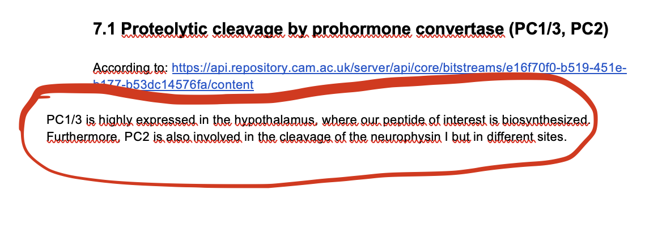
As noted in the beginning of the document, all notes made by your group are highlighted in green, therefore what is circled above should be green as well.

